**AUTOMATED TRAFFIC DATA COLLECTION, STORAGE, AND REPORTING PLATFORM**

**Anthony Omowumi**

**B00892305**

[Anthony-O@ulster.ack.uk](mailto:Anthony-O@ulster.ack.uk)

***Abstract- Understanding the predicted traffic load on the road is essential to any road construction. Therefore, this paper aimed to investigate the current traffic data collection, storage, reporting, and information-gathering methods. The results of the study, which used Lagos State, Nigeria as a case study, showed that the current process is a manual one, in which data collection is carried out manually by some trained group of people or surveyors who go out to take count of various vehicles moving on the road in a specific location at a specific time interval. This method's weakness results from the data's significant error rate. Even though past data that allows for prediction is not yet available, the data quality could be compromised, making the data dirty, inconsistent, and non-conforming. This would defeat the primary goal of data collecting in the first place. Sample data from location 01 – Towards Mile 2 – Westbound, along Lagos Badagry Expressway, Lagos State, Nigeria between 21st July – 25th July 2022 was used in this study. The process, the data collecting template, the categories of vehicles tallied, and the time for each count were all understood using the sample data. Furthermore, it was discovered that the data was stored mostly on hard drives, and flash drives, and was entered into an Excel spreadsheet, making the data particularly vulnerable to errors in data collecting, counting, or entering. By using artificial intelligence traffic cameras in place of manual counting, creating a data warehouse, and including a reporting software tool in the solution, this study led to the development of an effective business intelligence solution for Engineers when it comes to Road Construction.***

***Keywords: Construction, Road Construction, Data warehouse, Traffic, Internet of Things, Artificial Intelligence Camera, Data Collection, Storage, Reporting Platform and Business Intelligence***

1. INTRODUCTION

The construction sector is an important sector in the development of an economy. It is one of society’s weapons among others for achieving its objectives for urban and rural development. However, due to the intricacy of the building process itself and the substantial number of parties involved in it, including clients, users, designers, regulators, contractors, suppliers, subcontractors, and consultants, it is growing increasingly complex. Cost, time, and quality show a great measure to be the three main indicators of a project's success [1]. To select a cost-effective design for road construction, it is essential to be aware of and understand the traffic load to be expected on that road [2]. An understanding of the traffic load helps in the construction of the road quality, which also gives insight into the cost that will be needed in constructing the road. Traffic load prediction serves a major role in the start of a road construction project. To be aware of the traffic load on the road, adequate measures should be properly set in place to be able to get the count of vehicles passing through the road daily during a particular time, proper storage system and methods with an adequate reporting platform.

A previous laydown system that has been in use within the Construction Sector in Nigeria is a manual approach to collecting the data needed to get an insight into the traffic load on the road. Manual Data Collection as shown in Figure 1, Manual Data Entry into Excel, and Storage on a hard drive was the mode of Traffic Data Collection and Storage, these could lead to error in data quality (Clean, Consistent, Conformed, Current-might be updated but has non-availability to historical data which can be helpful in making insightful decisions and lastly, comprehensive) also knows as Data 5C’s.

Therefore, this study is aimed at proposing how business intelligence (BI) solutions can be incorporated into the system. Instead of Manual Traffic Data Collection, Storage, and Reporting, an automated traffic data collection, storage, and reporting platform. One of many BI solutions proposed in this study is the use of an Internet of Things (IoT) in Traffic Cameras (AI Cameras) as shown in Figure 2.

The idea of linking any gadget to the Internet and other linked devices is known as the "Internet of Things." This is only possible if the device has an on/off switch. The Internet of Things (IoT) is a vast network of interconnected devices and people, all of which gather and exchange data about their environments and how they are used [6]. For monitoring traffic scenes such as highways or two-lane roads, Traffic Camera is a perfect tool. It is adequate for getting advanced traffic statistics such as category counts for given periods, gap times, level of service, and many more [8]. In this study, Lagos state Nigeria will be used as a case study.

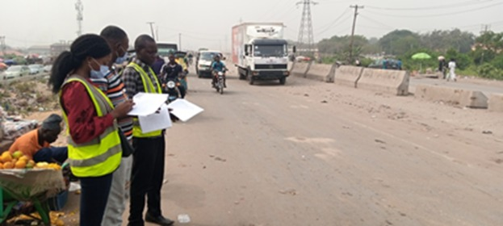

*Figure 1: Manual Data Collection Process*

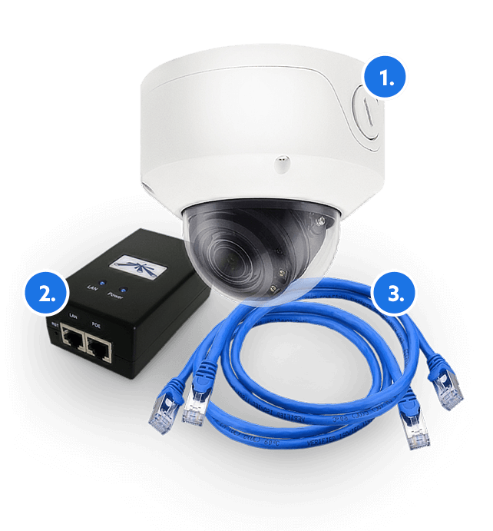

*Figure 2: Traffic Camera starter kit [8]*

1. METHODOLOGY

A Manually Classified Count data collected on location 01 - Towards Mile 2 Westbound, Along Lagos Badagry Expressway, Lagos State, Nigeria between 21st July and 25th July 2022 was used for the analysis in this study. Although already clean and entered Excel tool. Python, a data analysis tool was used to get some insight into the information in the data and summary statistics of the dataset as shown in Figure 3 and Figure 4.

*Figure 3: The information of the dataset and features it contains.*

*Figure 4: shows the statistical summary of the data collected*

1. Data Collection

Data collection was done manually using the template shown above in Figure 5.

*Figure 5: The Data Collection Form Template*

The collected features in the dataset period, date, and time including the categories of vehicles. The count was manually taken (Figure 1) from 6:15 am to 6 pm on a chosen day/date. The time was subdivided to allow for easy classification and visualization as shown in Table 1.

The current approach of collecting data manually is not a perfect approach as many factors can affect the accuracy of the data collected and thereby affect the road design or Business decision-making. The approach is prone to human errors during counting or during data entry. Therefore, this paper seeks to propose the use of Traffic Cameras as shown in Figure 2 for monitoring and taking the counts of the vehicles.

*Figure 6: Traffic Camera Count Operation at night [8]*

1. Data Storage

The data collected was usually stored in various kinds of hardware such as hard drives and Flash drives. Even though it is a portable type of storage, it is not the most effective way of storing essential data permanently. The proposed BI solution which is the artificially Intelligent Traffic Cameras (See Figure 2) is a great standalone device that allows for easy access to the data captured by connecting the traffic camera to a network router via computer network cables. The data captured is then accessed through a software called FLOW Traffic Application [8]. After this, the data can then be transferred into a Data Warehouse. The proposed BI solution for the storage situation is the use of a Data Warehouse either on-premises or on the cloud. A data warehouse, a vital component of business intelligence, combines data from numerous sources into a single data repository for complex analytics and decision support.

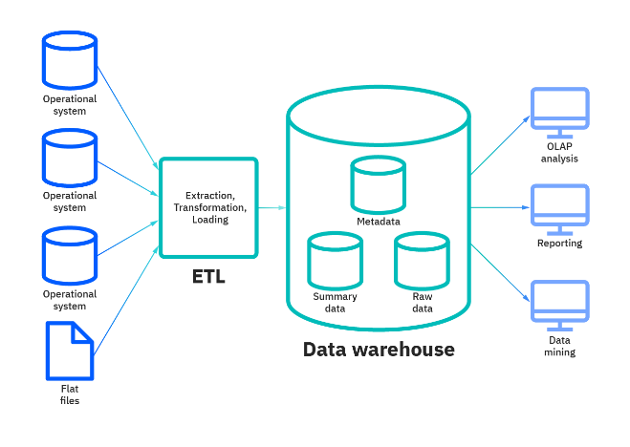

*Figure 7: General Data warehouse structure by IBM [9].*

1. Reporting and Visualization Platform

A good reporting platform built and incorporated into an organizational system will help in making timely and reliable decisions. It won’t be possible if a proper Data warehouse has been in place.



*Figure 8: Reporting Image*

When it comes to the reporting process, reporting software provides an organization with faster, more accurate, and more efficient alternatives than Excel. A good reporting platform helps in automating business reports by collecting data from the data warehouse and creating an insightful report in a fraction of the time that it would normally take [10].

Therefore, a BI reporting platform is proposed to be used for the reporting of the data captured.

Figures 9 and 10, show some of the insight that was gotten from analyzing and visualizing the data.

*Figure 9: Traffic Volume by Time Classification*

*Figure 10: Reporting Dashboard Built from the data captured.*

1. RESULTS

The summary of this study is to provide an alternative to the current data collection, storage, and reporting approach. This study has been able to suggest a BI solution approach to the methodology in place using an Artificial Intelligence Traffic Camera, the building of a Data Warehouse, and lastly the use of Reporting software to communicate the insight in the data to end users. This proposed BI Solution erases data errors in whatsoever ways and increases the potentiality of the data 5Cs.

1. DISCUSSION

This study uses Lagos State, Nigeria, as a case study, Examining the current approach to get traffic data collection, storage, and reporting. The data used for this analysis was one of the data manually classified collected data on location 01 – Towards Mile 2 – Westbound, along Lagos Badagry Expressway, Lagos State, Nigeria between 21st July – 25th July 2022. A Non-Disclosure Agreement was signed with the Data Owner Company to this effect.

Lagos state is the second most populous city in Africa and the largest city in Nigeria, with a population of 15.4 million individuals as of 2015[11]

In the development of any infrastructure, which includes roads, the design phase is important. Traffic information must be gathered for the design to move forward so that engineers may understand how the road will be used following construction or renovation. The current approach to getting the traffic information is known as a Manual Data Collection method by sending trained surveyors to get the count of different vehicles by their categories (e.g., cars, trucks, and buses in their various sizes) as shown in Figure 1. This approach can lead to improper records, miscounting of the vehicles, or even counting the wrong vehicle for another (biases), in short, it is prone to human errors. After the manual data collection method, the data collected is then passed to the data entry personnel, it is then entered into the computer system using the Excel spreadsheet application, this could lead to data mishandling, missing, and/or inaccurate entry. Following the approach, it is clearly seen that the Data Quality can be affected by the process. The approach is seen to be time-consuming, and prone to many errors. In case of multiple data imbalances/inconsistencies, the surveyors might have to be sent back to the field to collect another set of data which will amount to another cost and affect the project delivery time.

The proposed BI solution to the manual data collection, storage, and reporting is to automate the process by making use of AI Traffic Camera (IoT), building a data warehouse where the data can be automatically stored after being captured, and then, a reporting software’s in the likes of Microsoft PowerBI and others. This automated approach has clearly shown itself to be a new way forward as it would curb a lot of errors that the data could be exposed to. It is not time-consuming; it is less prone to errors, and it is more economical, and scalable. When the data is accurately reported by visualization, it can help some organizations, for example, an Advertising Company to know where and when an advert for a product should be more focused on because of the knowledge of the traffic count in that region. It can also help the region's people to know and predict the traffic count that might happen at a particular time of the day and determine their movement at that time. These and many more benefits can these give to society if the reporting is allowed for society to have access to.

1. CONCLUSION

The goal of this project is to give a Business Intelligence solution to the country. It is to help the society and the government of Nigeria understand the power of technological solutions. It also serves as an advantage to the construction Industry (Engineers, Surveyors, and Architects). This solution is believed to be long-time if taken into consideration and in place. It would also contribute immensely to the economy's growth because road construction is an important project that also helps develop a country.

REFERENCES

|  |  |
| --- | --- |
| [1] | Mahamid, I., Bruland, A. and Dmaidi, N., "Causes of delay in road construction projects.," *Journal of management in engineering,* vol. 28(3), pp. 300-310, 2012. |
| [2] | Chai, J.C. and Miura, N., "Traffic-load-induced permanent deformation of road on soft subsoil," Journal of geotechnical and geoenvironmental engineering, vol. 128(11), pp. 907-916, 2002. |

|  |  |
| --- | --- |
| [3] | Elkin, D. and Vyatkin, V., "IoT in traffic management: review of existing methods of road traffic regulation.," *In Computer science on-line conference. Springer, Cham.,* pp. 536-551, July 2020. |
| [4] | Atubi, A.O., "Road transport system management and traffic in Lagos, South Western Nigeria," *African Research Review,* vol. 4(4), 2010. |
| [5] | Assessment of Road transport Infrastructure in Lagos State , "Researchgate," 05 July 2022. [Online]. Available: https://www.researchgate.net/publication/359160294. [Accessed 06 December 2022]. |
| [6] | What is the Internet of Things(IoT), "IBM," IBM, 17 November 2016. [Online]. Available: https://www.ibm.com. [Accessed 06 December 2022]. |
| [7] | About Lagos – Lagos State Government, "Lagos State Government," [Online]. Available: https://www.lagosstate.gov.ng. [Accessed 06 December 2022]. |
| [8] | Traffic Monitoring and Management, "Datafromsky," [Online]. Available: www.datafromsky.com. [Accessed 07 December 2022]. |
| [9] | What is Data warehouse, "IBM Cloud Education," 05 March 2020. [Online]. Available: www.ibm/cloud/learn/data-warehouse. [Accessed 08 December 2022]. |
| [10] | What is Reporting Software?, "Predictive Analytics," 2022. [Online]. Available: www.predictiveanalyticstoday.com. [Accessed 08 December 2022]. |
| [11] | Wikipedia, "Wikipedia, the free encyclopedia," [Online]. Available: https://en.wikipedia.org/wiki/Lagos. [Accessed 09 December 2022]. |